DAT 530 uCertify Lab Activity Worksheet

Module Labs
- 1.2.7 Reading Data From a File
- 1.2.5 Viewing Data From a Data Set
- 1.2.3 Adding a Column to a Data Set
- 1.2.6 Deleting a Column From a Data Set

Lab Screenshots
- 1.2.7 Reading Data From a File
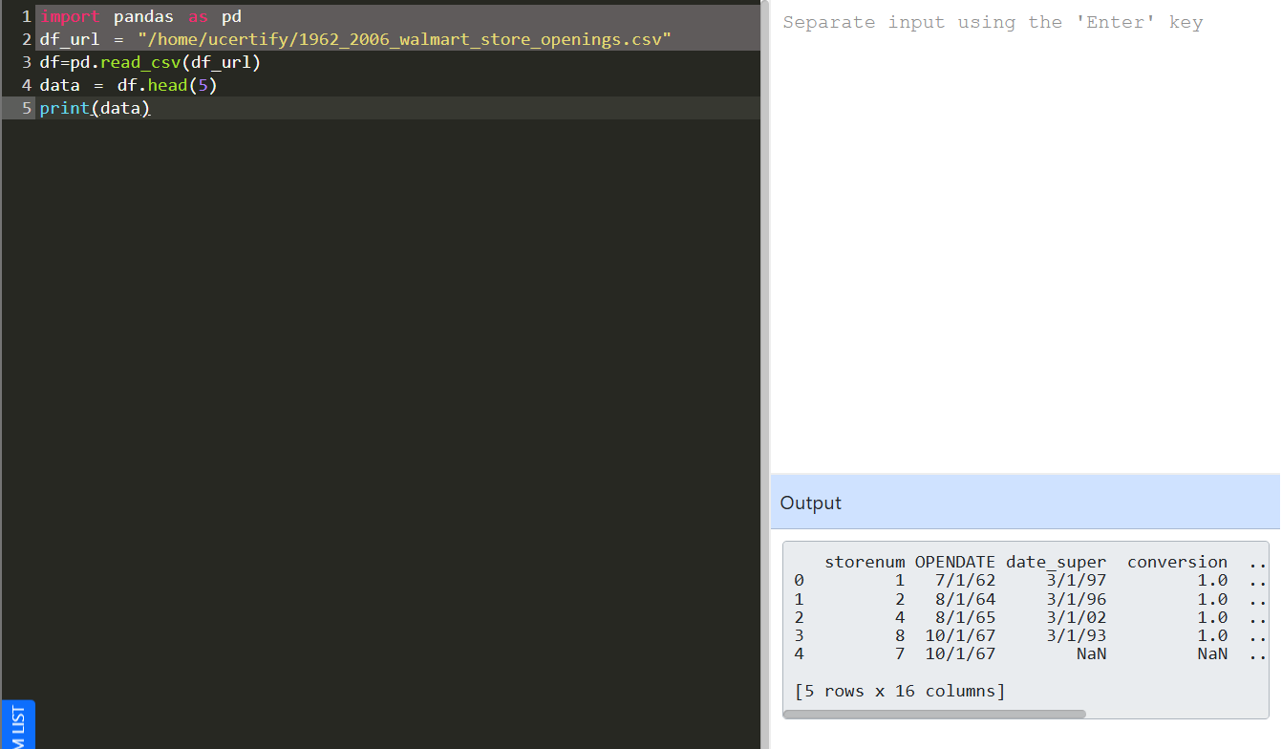
- 1.2.5 Viewing Data From a Data Set
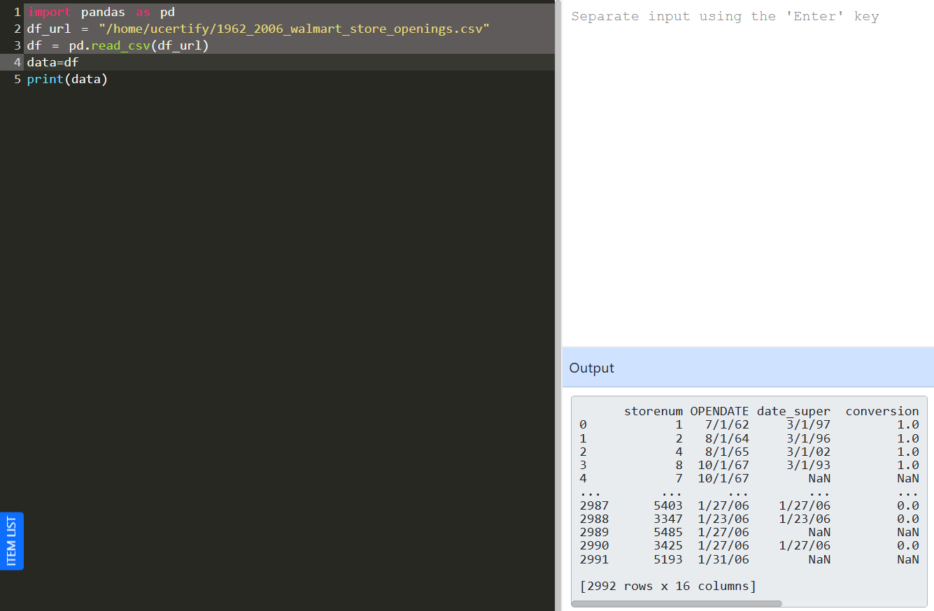
- 1.2.3 Adding a Column to a Data Set
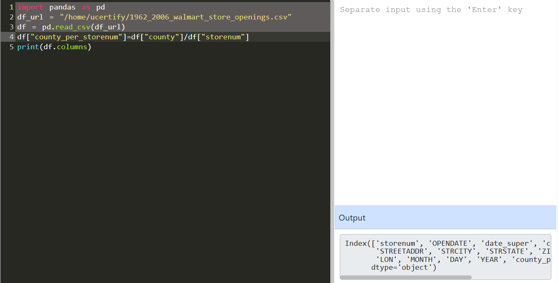
- 1.2.6 Deleting a Column From a Data Set
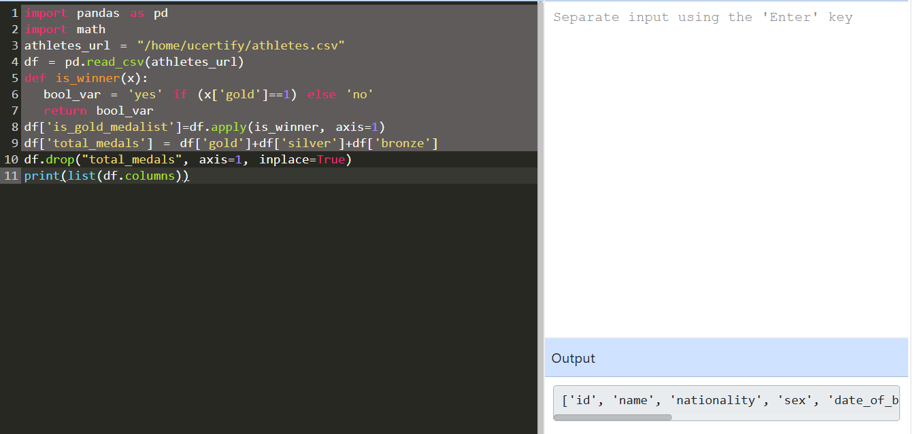

Lab Reflection
- 1.2.7 Reading Data From a File
I practiced the pandas DataFrame function with a CSV file, and learnt how to utilize it using the line df = pd.read_csv(df_url). The initial phase of any data analysis is to read the data from an external file . All the other , i.e. data purification , exploration , and visualization , is based on this . Here we’ve concentrated on loading data, not showing it, yet visualizing data is a core skill of data analysts, data scientists, and BI professionals.

- 1.2.5 Viewing Data From a Data Set
In this lab, I learnt how to load a CSV file in a DataFrame and display its contents. The essential piece of code that allowed for printing and viewing of the dataset was data = df. Viewing data is an important first step to understand a dataset before doing any analysis or visualizations. This process will be useful for data scientists, analysts and anyone whose job is to check data quality prior to drawing conclusions.

- 1.2.3 Adding a Column to a Data Set
In this lab I got to explore creating new calculated columns by applying mathematical techniques to preexisting columns in a pandas DataFrame. This code snippet demonstrates how Python may generate new data for analysis from existing datasets without modifying the original data: df[“county_per_storenum”] = df[“county”] / df[“storenum”]. This lab did not create a representation, however data preparation and conversion is an important step before building charts or dashboards. These methods will be useful to you if you are a business user or data analyst looking for computed fields to utilize in your reports or visualizations.

- 1.2.6 Deleting a Column From a Data Set
The aim of this project was to delete any unneeded data from a DataFrame. with df.drop('total_medals', axis=1, inplace=True) Delete superfluous columns before visualizing your data. This will make your research easier and simpler. That’s a critical stage for certain reporting without the photographs. Analysts might employ these strategies to prepare data for dashboards and presentations to business personnel.

